|  |  |
| --- | --- |
|  | SR UNIVERSITY  Campus Warangal |
| Program: II - B.Tech (CS& AI) |
| Professor(a): Dr. Venkataramana Veeramsetty, Professor |
| Department: Computer Science and AI Semester: I |
| AI Assisted Coding - Lab Test 1 - Set C |
| Instructions:   1. Use AI Tools like VScode+Github Copilot and Cursor AI for code generation 2. This Assignment will be evaluated for 15 Marks (10 Marks for Tasks and 5 Marks for viva based on regular lab activities) 3. Students need to submit assignment through canvas before due date 4. Students who are absent for lab will receive 0 Marks | |

1. (2 Marks) Write a Python program to extract all URLs (web links) from a block of text using regular expressions. Use the Cursor AI tool with zero-shot prompting to generate the solution
2. (2 Marks) Given a list of books with their genres, write a Python function that recommends books based on a user’s preferred genre. Use the Cursor AI tool. Use few shot prompting.
3. (2 Marks) Write a Python program that generates all prime numbers between start and end (both inclusive) entered by the user. Use GitHub Copilot along with VS Code. Use few shot prompting.
4. (2 Marks) Write Python code that takes a list of student names and generates institutional email IDs in the format: <firstletter><lastname>@sru.edu.in Example: "Anita Sharma"→ asharma@sru.edu.in. Use GitHub Copilot along with VS Code. Use few shot prompting. Date: 2025-08-14
5. (2 Marks) Write a Python program to extract all URLs (web links) from a block of text using regular expressions. Use the Cursor AI tool with zero-shot prompting to generate the solution

Prompt:write a python code to extract all urls from a block of text using regural expression. 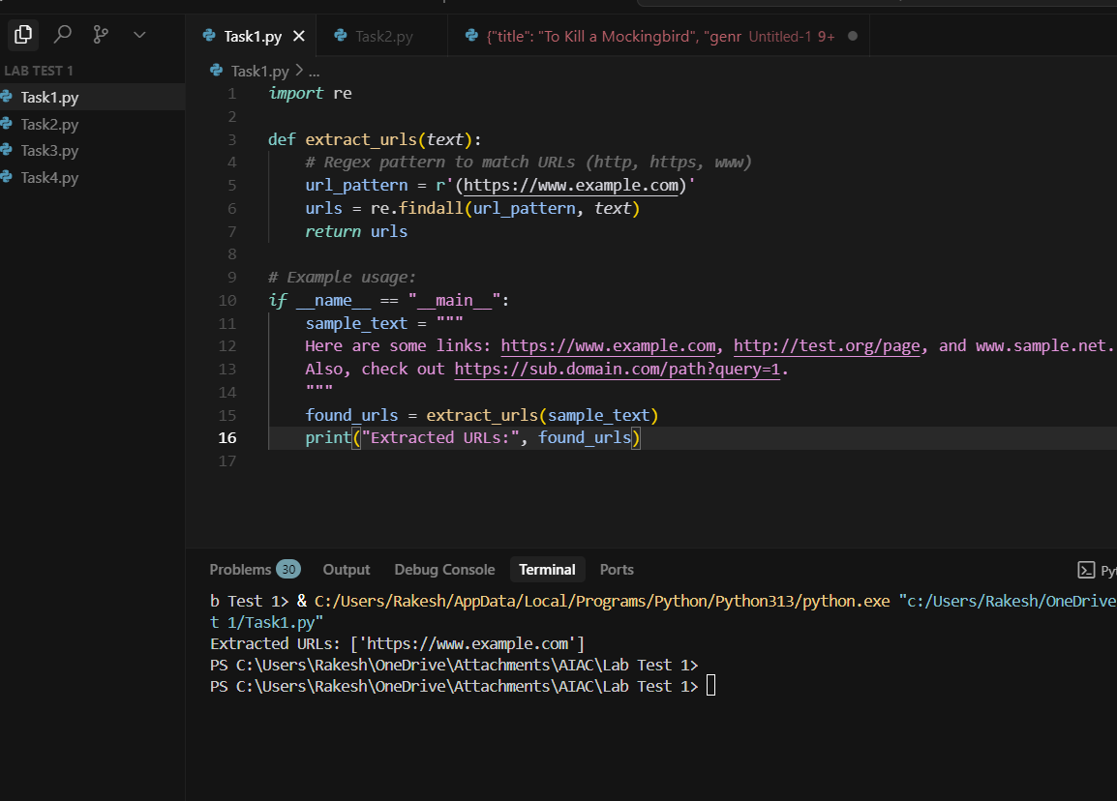

1. (2 Marks) Given a list of books with their genres, write a Python function that recommends books based on a user’s preferred genre. Use the Cursor AI tool. Use few shot prompting

Prompt:write a python code,that reads list of books with there generates and recommends books based on gener.Examples:1.Title=The story of king,Gener=classic.2.Title=The name of wind,gener=Fantasy.If the user enter gener=Classic then output=The story of king

3. (2 Marks) Write a Python program that generates all prime numbers between start and end (both inclusive) entered by the user. Use GitHub Copilot along with VS Code. Use few shot prompting.

Prompt:write a python code,that reads and generates all prime numbers between range by the user.

Examples:1.range=1-6 then prime numbers=3,5.

2.range=1-9 then prime numbers=3,5,7.

Code: 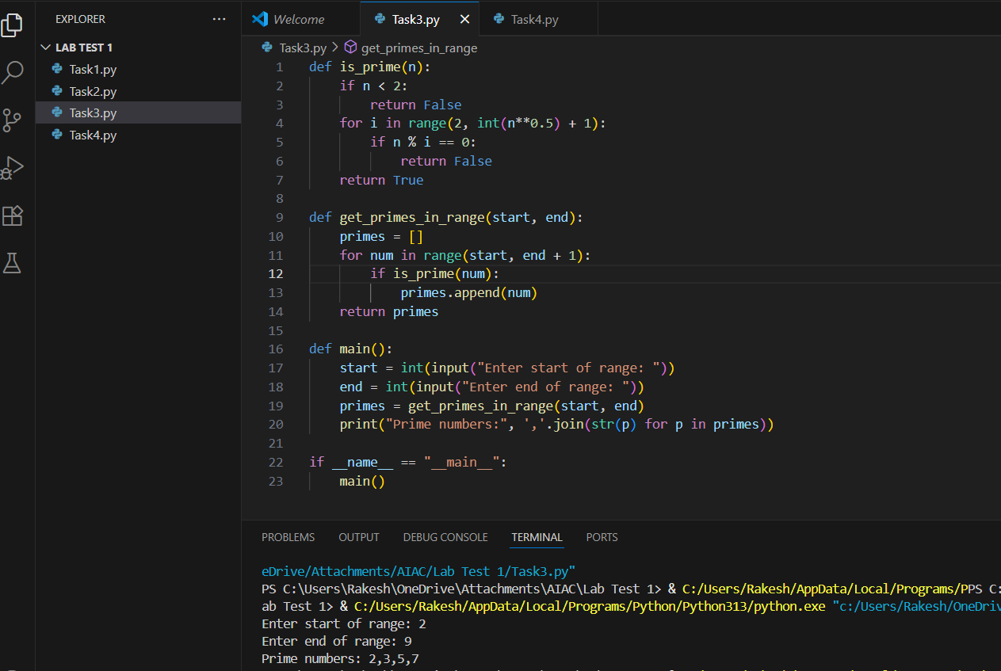

4.(2 Marks) Write Python code that takes a list of student names and generates institutional email IDs in the format: <firstletter><lastname>@sru.edu.in Example: "Anita Sharma"→ asharma@sru.edu.in. Use GitHub Copilot along with VS Code. Use few shot prompting

Prompt:Write a python code,that reads list of students names and generates institutional emails ids in the format :<first name><last name>@sru.edu.in.Examples:1.Savin Thallapelly->[stall@sru.edu.in,2.Srinath](mailto:stall@sru.edu.in,2.Srinath) Poodiri->spoo@sru.edu.in. 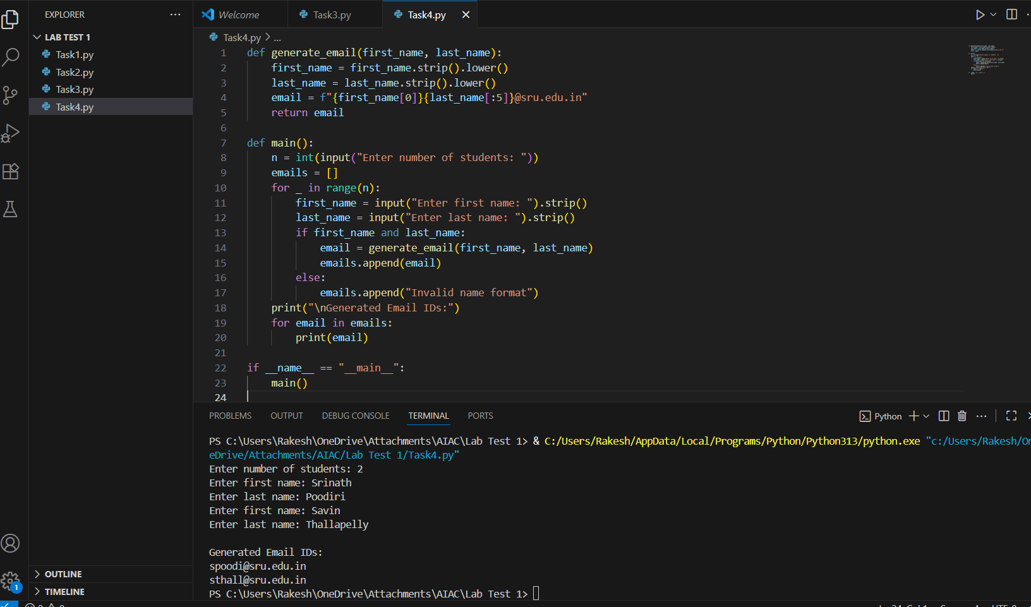

©Dr. Venkataramana Veeramsetty, Professor Pag. 1 de 1